Spell Check: Base Word + Inflection: Plurals, Irregular Plurals

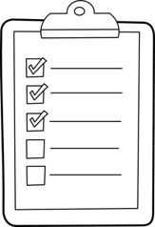

Name ______________________________

*Read each sentence carefully and look at the underlined word. Complete each sentence by changing the underlined word to the* ***plural form****. Write the* ***plural form*** *of the word in the bank provided.*

1. I have one dress but she has two ________________________.
2. The basketball team has one coach but the football team has three ____________________.
3. Each new month gets us closer to the ________________ ahead.
4. I cannot see very well with one eye shut but I can see perfectly with both ________________ open.
5. We moved from house to house. By the end of three years we had lived in four different________________!
6. I wore my green watch today so I will wear my red and blue ________________ later this week.
7. One fly won’t bother me but six _______________ will make me crazy!
8. I hurt my foot in gym class. Luckily, I have two _______________!
9. The last child out the door ran to the other _________________ on the playground.
10. The mother fox brought food back to the den to feed the baby ________________.

Write the plural form of each word below.

1. cry ____________________
2. friend ____________________
3. change ____________________
4. flash ____________________
5. goose ____________________
6. box ____________________